Day 2

1. Alter Table:

* Add a new column linkedin_profile to employees table to store LinkedIn URLs as varchar.

ALTER TABLE employees ADD COLUMN linkedin_profile VARCHAR(100);

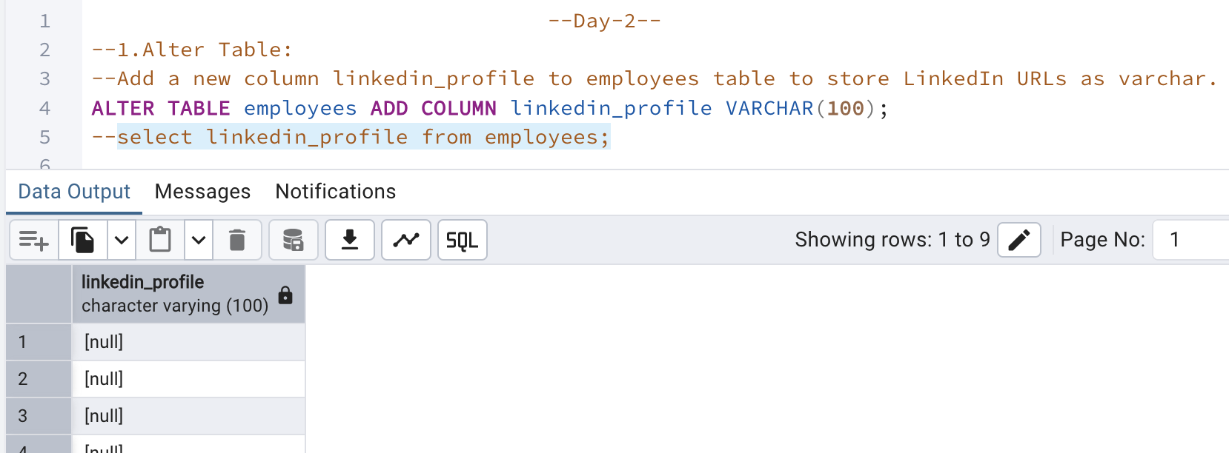

* Change the linkedin_profile column data type from VARCHAR to TEXT.

ALTER TABLE employees ALTER COLUMN linkedin_profile TYPE TEXT;

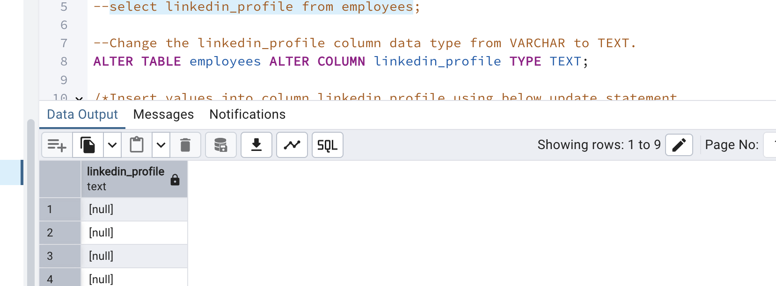

* Add unique, not null constraint to linkedin_profile

/*Insert values into column linkedin_profile using below update statement

UPDATE employees SET linkedin_profile='emp'||employeeid||'@gmail.com';*/

--Add unique, not null constraint to linkedin_profile

ALTER TABLE employees ALTER COLUMN linkedin_profile SET NOT NULL;

ALTER TABLE employees ADD CONSTRAINT linkedin_profile_unique UNIQUE(linkedin_profile);

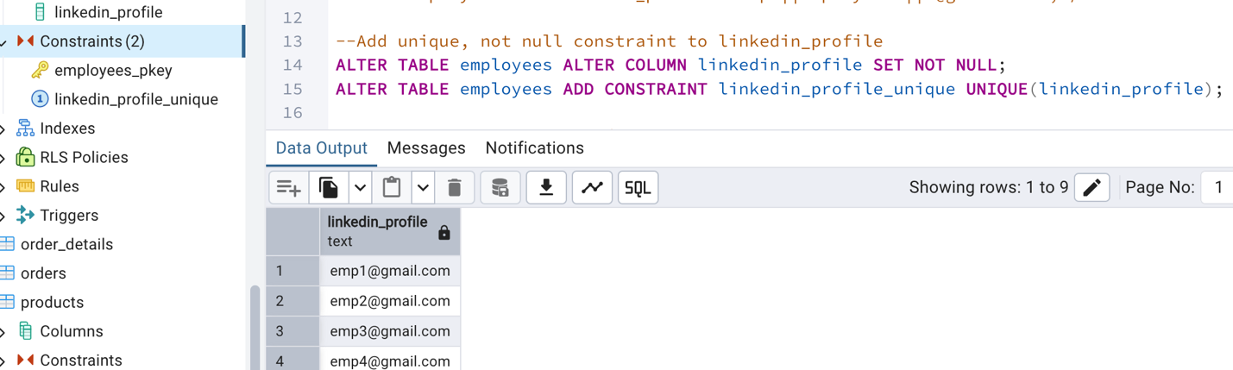

* Drop column linkedin_profile

ALTER TABLE employees DROP COLUMN linkedin_profile;

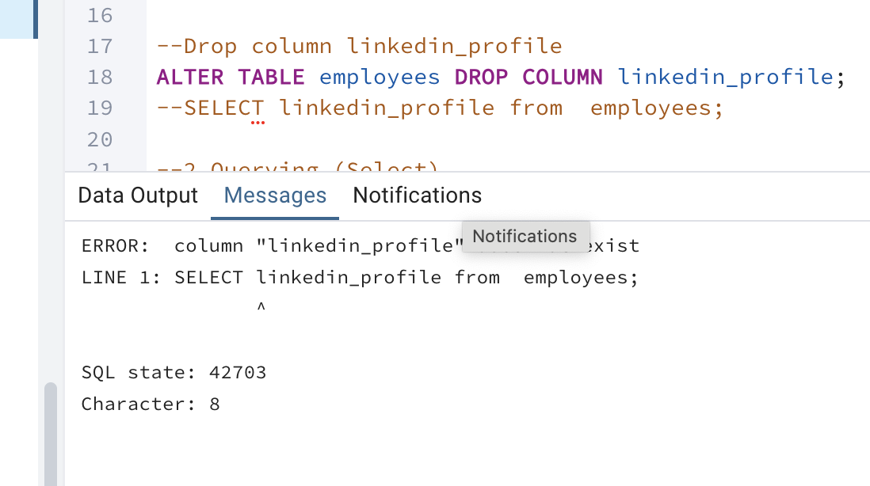

2. Querying (Select)

* Retrieve the employee name and title of all employees

SELECT employeename, title FROM employees;

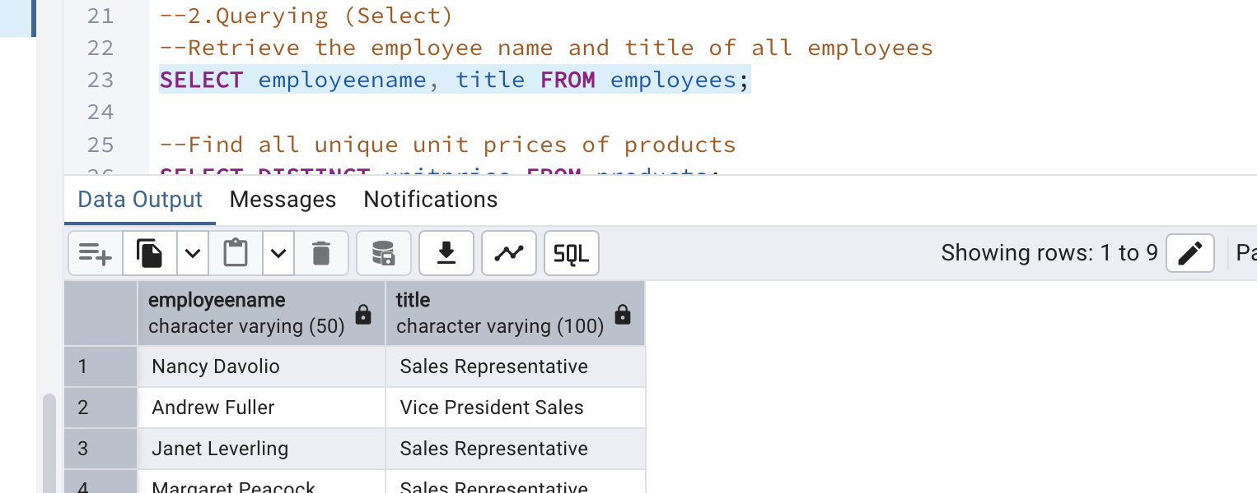

* Find all unique unit prices of products

SELECT DISTINCT unitprice FROM products;

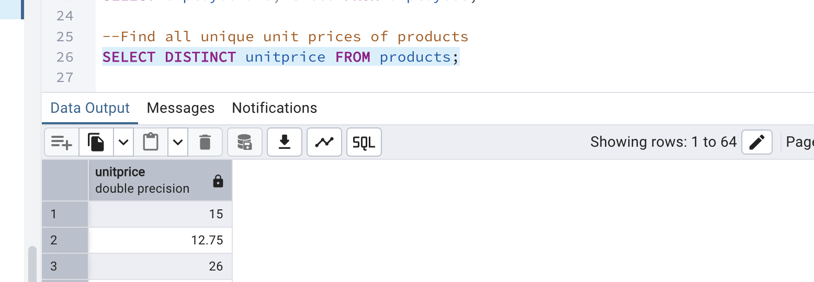

* List all customers sorted by company name in ascending order

SELECT * FROM customers ORDER BY companyname asc;

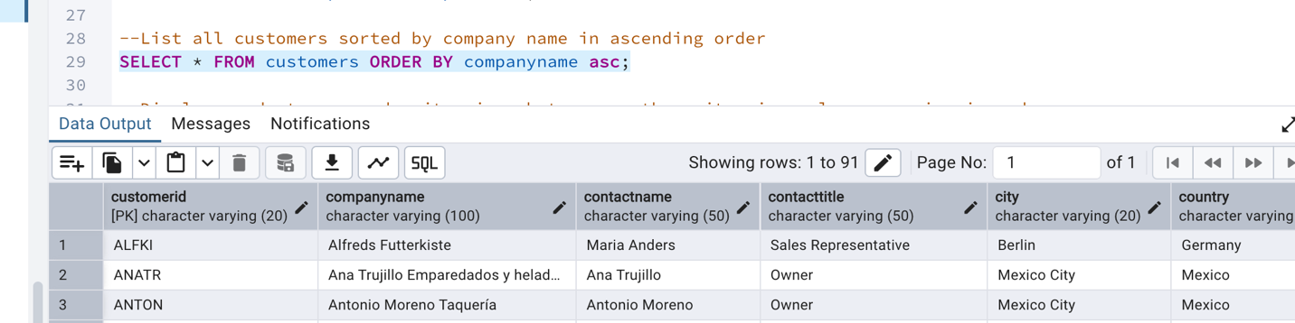

* Display product name and unit price, but rename the unit_price column as price_in_usd

SELECT productname, unitprice AS "price_in_usd" FROM products;

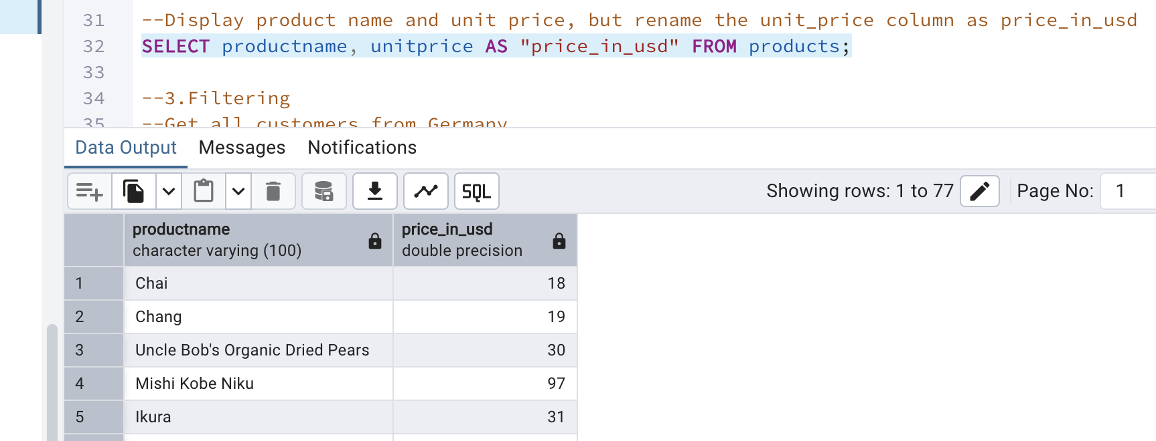

3. Filtering

* Get all customers from Germany.

SELECT * FROM customers WHERE country='Germany';

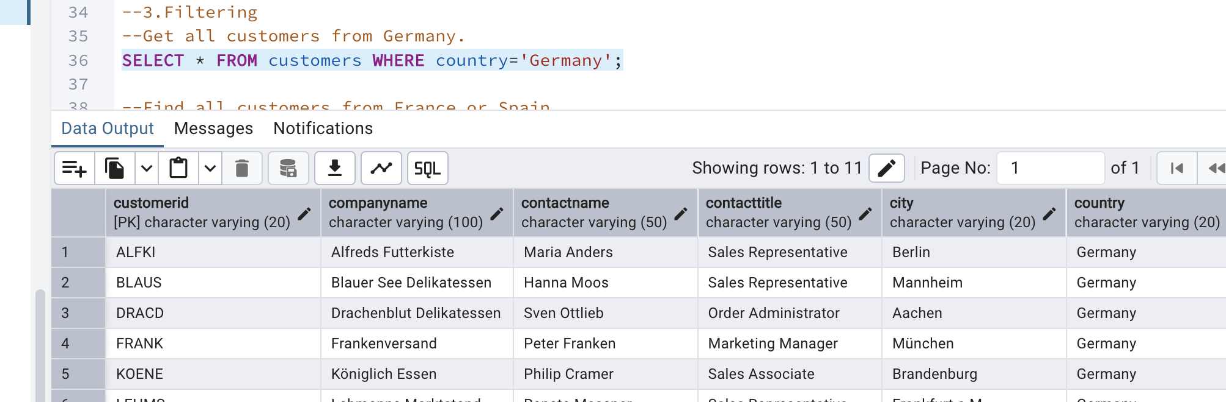

* Find all customers from France or Spain

SELECT * FROM customers WHERE country IN ('France','Spain');

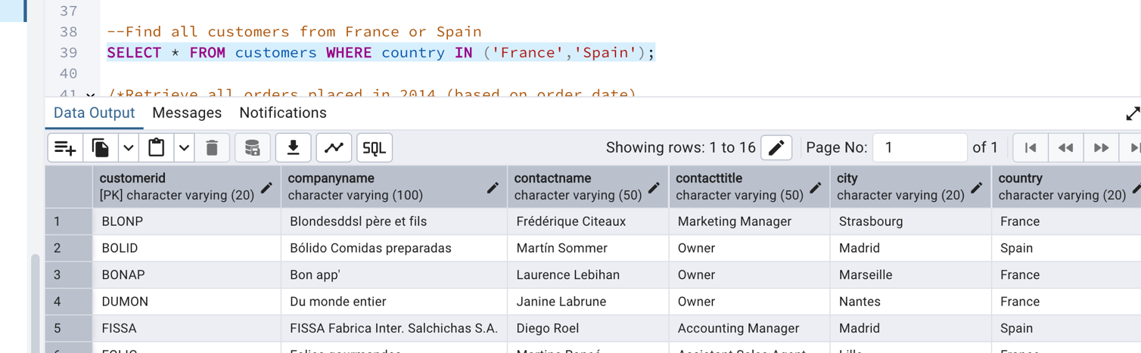

* Retrieve all orders placed in 2014(based on order_date), and either have freight greater than 50 or the shipped date available (i.e., non-NULL)  (Hint: EXTRACT(YEAR FROM order_date))

SELECT * FROM orders WHERE (

EXTRACT(YEAR FROM orderdate )=2014 AND(freight>50 OR shippeddate IS NOT NULL)

);

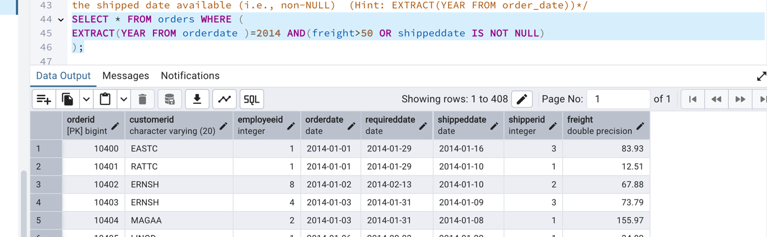

4.  Filtering

* Retrieve the product_id, product_name, and unit_price of products where the unit_price is greater than 15.

SELECT productid,productname,unitprice FROM products WHERE unitprice>15;

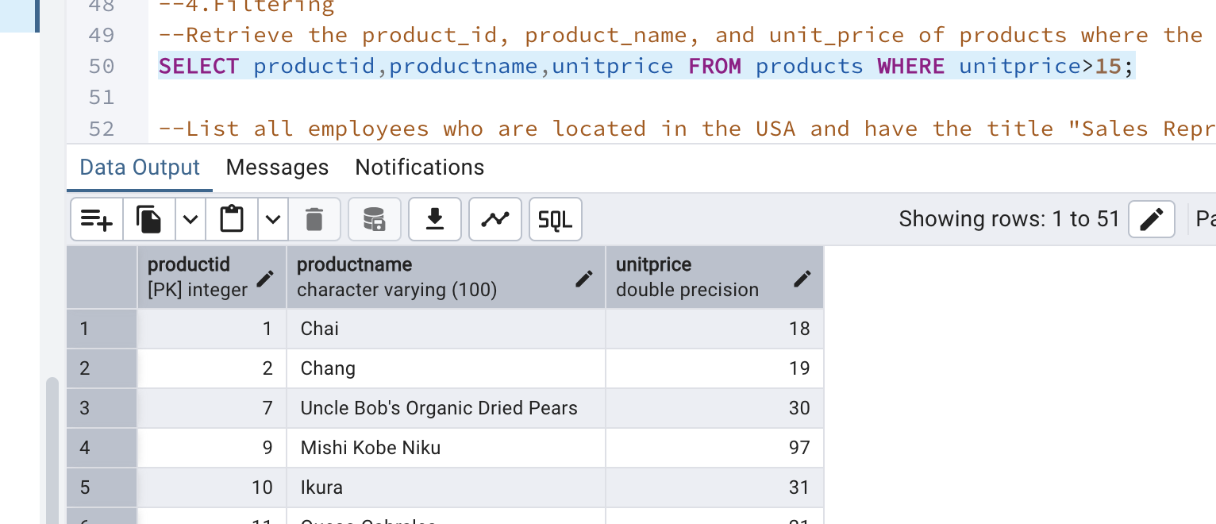

* List all employees who are located in the USA and have the title "Sales Representative".

SELECT * FROM employees WHERE country='USA' AND title='Sales Representative';

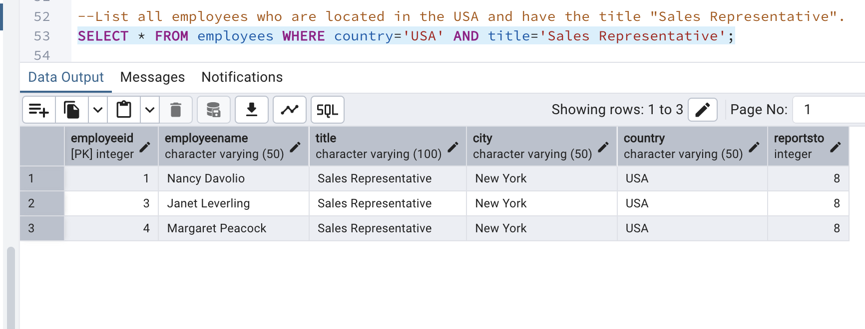

* Retrieve all products that are not discontinued and priced greater than 30.

SELECT * FROM products WHERE discontinued<>1 AND unitprice>30;

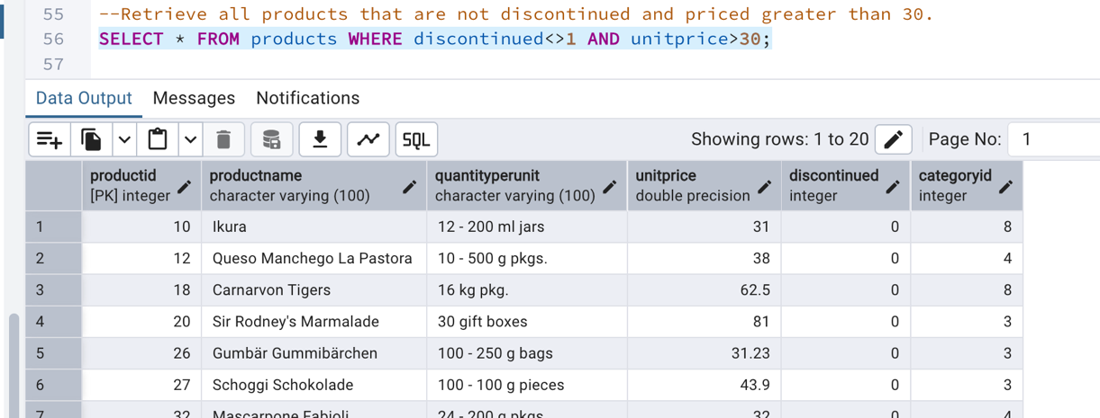

5. LIMIT/FETCH

* Retrieve the first 10 orders from the orders table.

SELECT * FROM orders LIMIT 10;

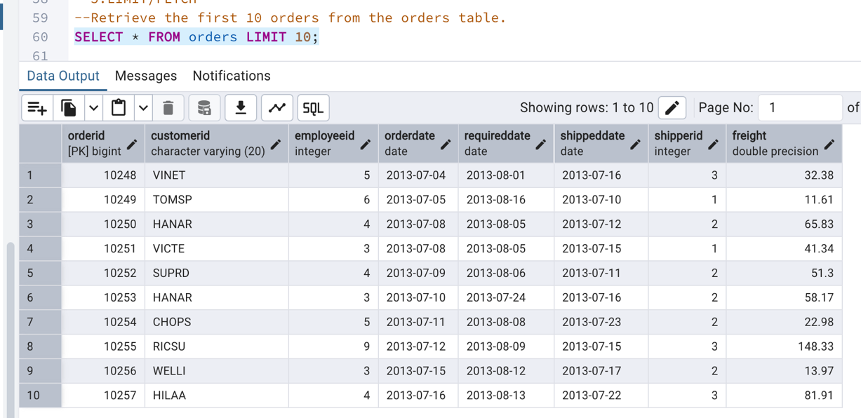

* Retrieve orders starting from the 11th order, fetching 10 rows (i.e., fetch rows 11-20).

SELECT * FROM orders LIMIT 10 OFFSET 10;

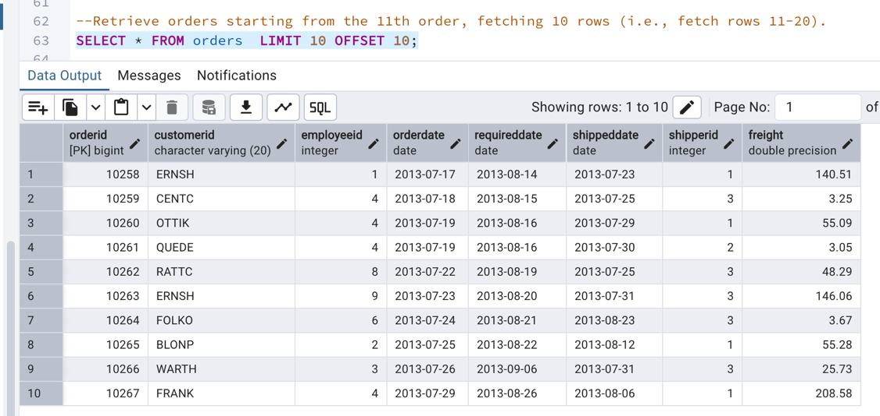

6. Filtering (IN, BETWEEN)

* List all customers who are either Sales Representative, Owner

SELECT * FROM customers WHERE contacttitle IN ('Sales Representative','Owner');

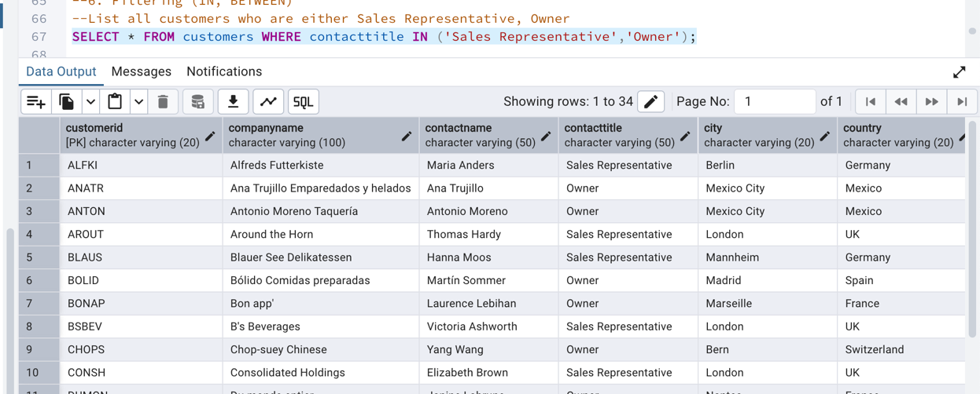

* Retrieve orders placed between January 1, 2013, and December 31, 2013.

SELECT * FROM orders WHERE orderdate BETWEEN '2013-01-01' AND '2013-12-31';

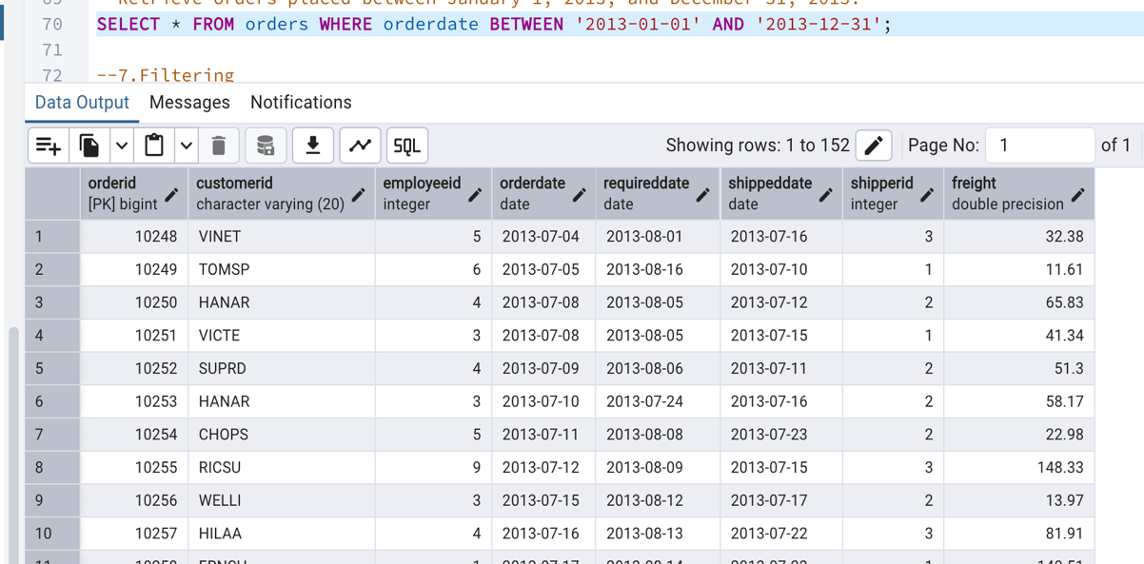

7. Filtering

* List all products whose category_id is not 1, 2, or 3.

SELECT * FROM products WHERE categoryid NOT IN (1,2,3);

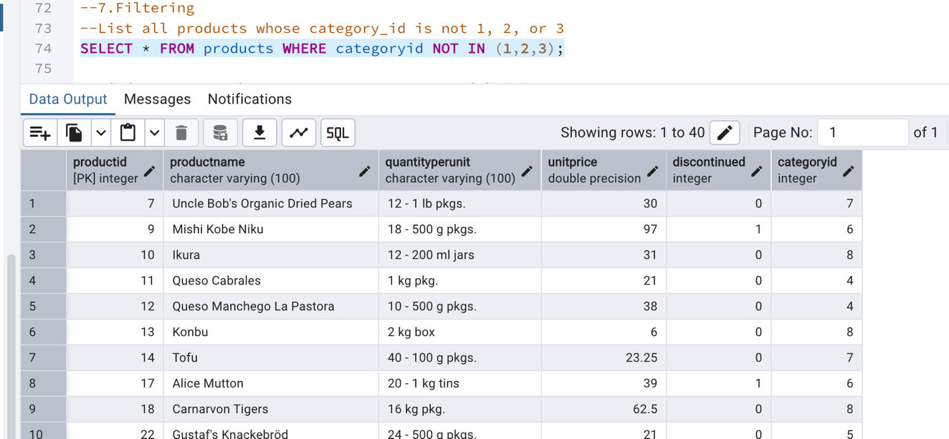

* Find customers whose company name starts with "A".

SELECT * FROM customers WHERE companyname LIKE 'A%';

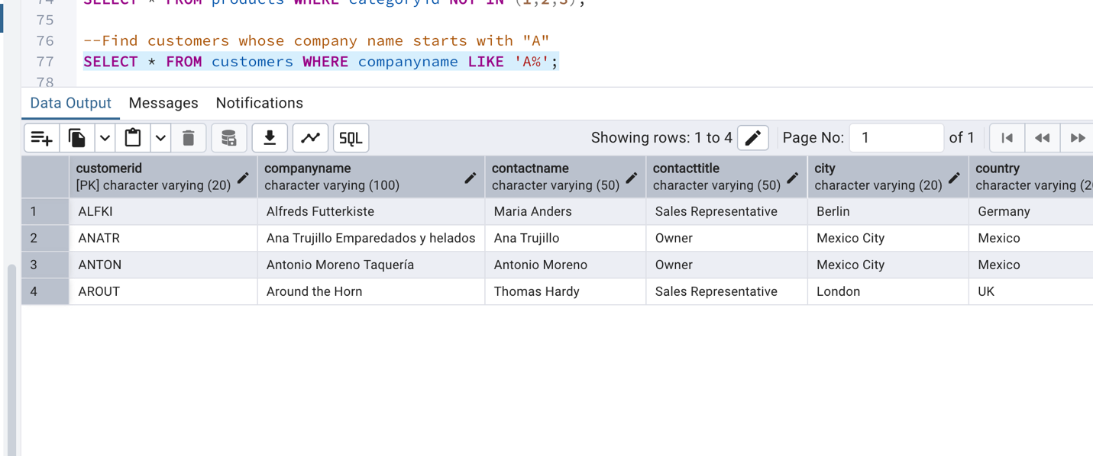

8)       INSERT into orders table:

 Task: Add a new order to the orders table with the following details:

Order ID: 11078

Customer ID: ALFKI

Employee ID: 5

Order Date: 2025-04-23

Required Date: 2025-04-30

Shipped Date: 2025-04-25

shipperID:2

Freight: 45.50

INSERT INTO orders (orderid,customerid,employeeid,orderdate,requireddate,shippeddate,shipperid,freight)

VALUES (11078,'ALFKI',5,'2025-04-23','2025-04-30','2025-04-25',2,45.50);

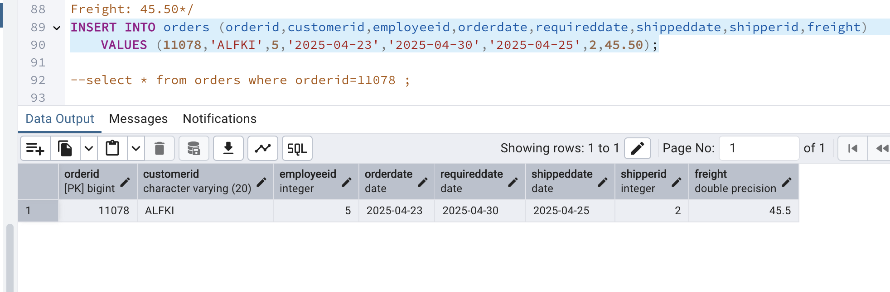

9)      Increase(Update)  the unit price of all products in category_id =2 by 10%.

(HINT: unit_price =unit_price * 1.10)

UPDATE products SET unitprice=(unitprice*1.10) WHERE categoryid=2;

